Team 5

Maria Ramirez

James Gonzales

Victor Baker

Courtney Hyland

Project 2: Sharks & Shipwrecks

Project 2 Github:

<https://github.com/cphyland/Project-2.git>

Data Source:

Shark data via API:

<https://catalogue.data.wa.gov.au/dataset/western-australia-s-govhack-shark-hazard-api/resource/ca305e6c-6b4b-40bc-a2be-f697fb9d24d1>

Shipwreck data via API:

<https://services.slip.wa.gov.au/public/rest/services/SLIP_Public_Services/People_and_Society/MapServer/0>

Are Ariel and Flounder in danger as they rummage through the shipwreck?

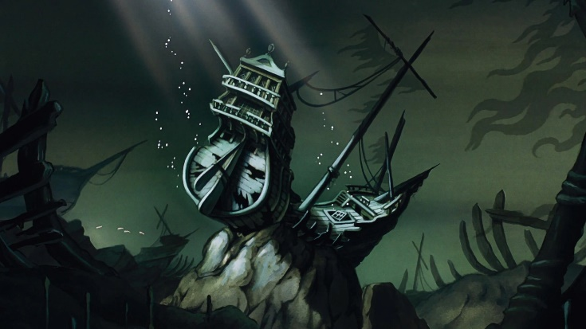

Using Python Flask-powered API, HTML/CSS, JavaScript, & the MongoDB, we intent to visualize shark movement and shipwreck locations to answer the question: Do sharks frequent shipwreck locations? Use the API data and Leaflet we will produce an interactive map that shows both shark locations including individual data/stats, shipwreck locations including ship data/stats. Users will be able to toggle between shark only, ship only and combined views.

1. Python Flask-powered API, HTML/CSS, JavaScript, & MongoDB
2. A combination of web scraping and Leaflet
3. JS Library Velocity
4. 100+ records (shark & shipwreck)
5. Will include dropdowns & textboxes
6. 3 views: shark locations, shipwreck locations, combination shark & shipwreck locations

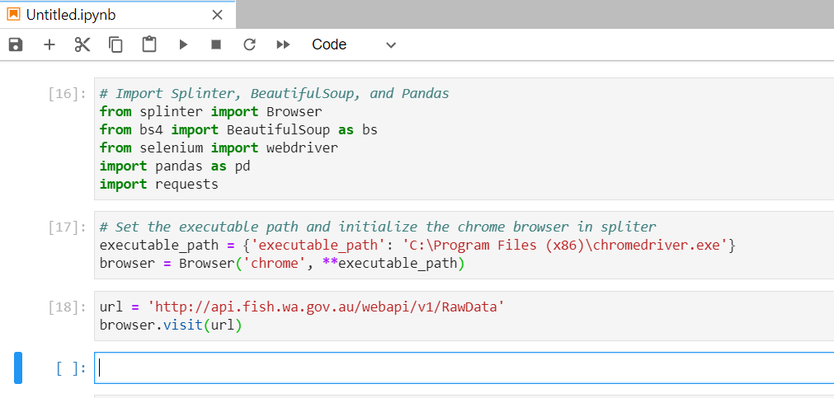

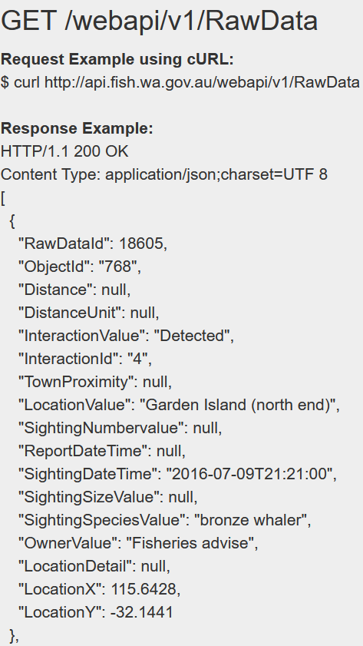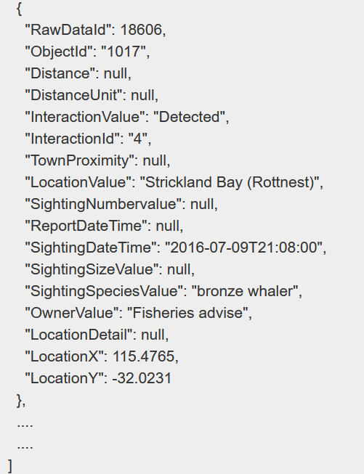

Shark Locations Visual Inspiration

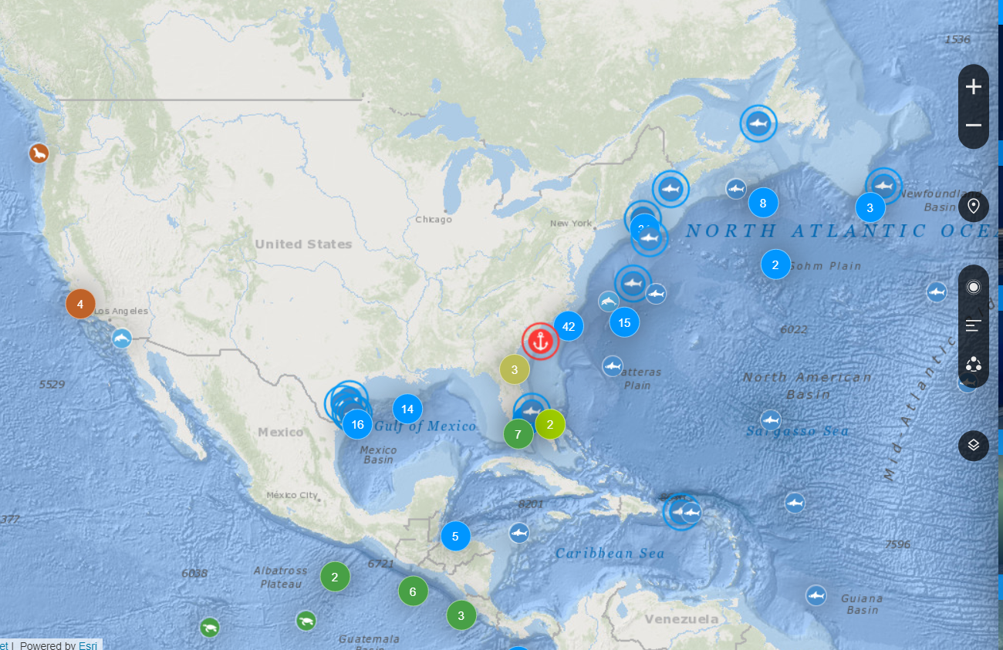

Shipwreck Locations Visual Inspiration

